Fundraising for Stage Reinstatement Project

Engraving of hall tiles (suggested minimum donation of £50; GOLD sponsorship £500)

Methods of Payment Gift Aid (adds 25% to the value of your donation)

- Bank Transfer (preferred) 2. Cheque (or Cash)

- Donations of any amount can most easily be made by bank transfer to:
Raynes Park High School Charitable Trust: Sort Code 30 99 66 Account 00297476
Please put your surname in the reference box
- If you would rather pay by cheque (or cash):
- post the cheque to our treasurer at:
RPHSCT c/o Higgins 145 Thetford Road, New Malden KT3 5DZ
- Alternatively you could drop the cheque (or cash) into school reception marking the envelope ‘Stage Project: for the attention of Eva Marino, Director of Finance’.
NB If you are a tax payer, we can claim gift aid. After you have made the donation, please complete the details below and return this form by e-mail to the Treasurer bobhiggins@virginmedia.com inserting RPHS Trust Gift Aid in the subject line.
Cheque/ cash donors please complete a hard copy and enclose in your envelope.
First Name: | Surname:
Postcode: | First line of address:

The treasurer will collect the gift aid from HMRC at the end of the tax year.
Donations of any amount are welcome. If you wish to engrave a tile in your name and/or another pupil’s name please supply the details below. See below for the suggested format:
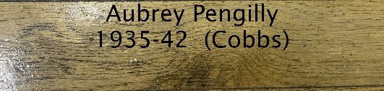
Please insert your name as you wish it to be engraved and your house (Cobbs, Gibbs, Halliwells, Miltons, Newsoms) and/or other names you are sponsoring and years you were at school:
HOUSE:

‘GOLD’ sponsors please detail how you wish your name/ name of your company to be displayed:

Any other comments:

